Project
  - Deadline: 9/8/2026 @ 23:59
[Total Mark for this Project is 14]

IT475
Decision Support Systems
Students Details:
CRN: 50271
Name: MOHAMMED ALSAHLI |  | ID: s230041469
Name: AMEER ALAWAMI |  | ID: s230026655
Name: MOHAMMED ALMURAYKHI |  | ID: s230025455
Name: RashedSalim |  | ID: S230043119
Name: ALLAL ALGHORYBI |  | ID: S220043911

Instructions:
- You must submit two separate copies (one Word file and one PDF file) using the Assignment Template on Blackboard via the allocated folder. These files must not be in compressed format.
- It is your responsibility to check and make sure that you have uploaded both the correct files.
- Zero mark will be given if you try to bypass the SafeAssign (e.g. misspell words, remove spaces between words, hide characters, use different character sets or languages other than English or any kind of manipulation).
- Email submission will not be accepted.
- You are advised to make your work clear and well-presented. This includes filling your information on the cover page.
- You must use this template, failing which will result in zero mark.
- You MUST show all your work, and text must not be converted into an image, unless specified otherwise by the question.
- Late submission will result in ZERO mark.
- The work should be your own, copying from students or other resources will result in ZERO mark.
- Use Times New Roman font for all your answers.

Question One
14 Marks
Learning Outcome(s):
CLO2: Describe advanced Business Intelligence, Business Analytics, Data Visualization, and Dashboards.
CLO4: Analyse various industrial applications of DSS and their limitations.
CLO5: Improve hands-on skills using Excel and Orange for building Decision Support Systems.

1. Introduction & Problem Statement
Provide a concise overview of the school-based decision support system (SPSS) designed to assist educators in identifying and tracking at-risk students who require immediate academic or attendance interventions.
For this sample, imagine a fictional school ("Riverside Elementary," 30 fictional students) where a teacher currently checks grades in one place and attendance in another. The training dataset simulates that problem: it gives each fictional student three test scores and an attendance percentage, so students practicing this project can see how combining two data sources into one flagging rule works.
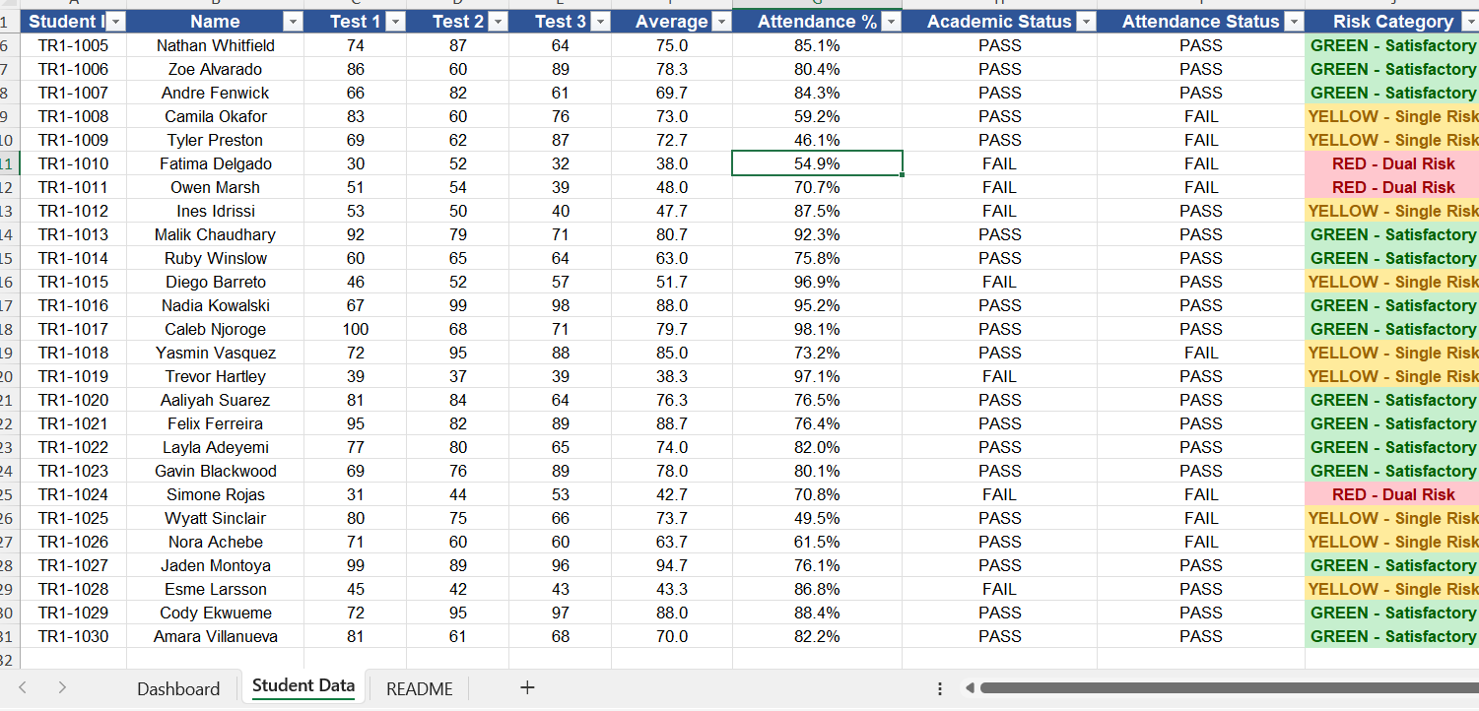

2. Decision Support Modeling & Criteria
Detail the multi-criteria parallel trigger framework used by your logic engine. Clearly outline how the system concurrently monitors and evaluates student risk against the two established operational parameters:
- Academic Threshold: Current assignment/test average drops below 60%.
- Attendance Threshold: Cumulative class attendance falls below 75%.
Answer:
Two thresholds, applied in parallel:
- Academic: average of Test 1–3 < 60 → FAIL
- Attendance: Attendance % < 75 → FAIL
In the Student Data sheet, these are three formulas per student:
Average =ROUND (AVERAGE (C2:E2),1)

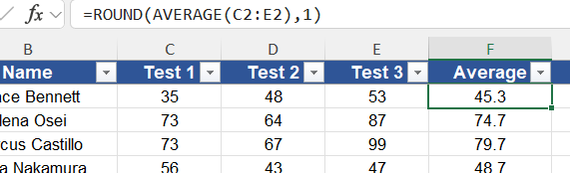

Academic Status =IF(F2<60,"FAIL","PASS")

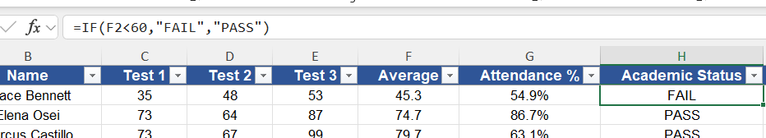

Attendance Status =IF(G2<75,"FAIL","PASS")

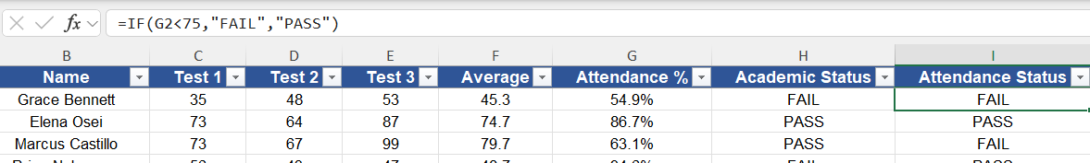

Risk Category =IF(AND(H2="FAIL",I2="FAIL"),"RED - Dual Risk",
IF(OR(H2="FAIL",I2="FAIL"),"YELLOW - Single Risk","GREEN - Satisfactory"))

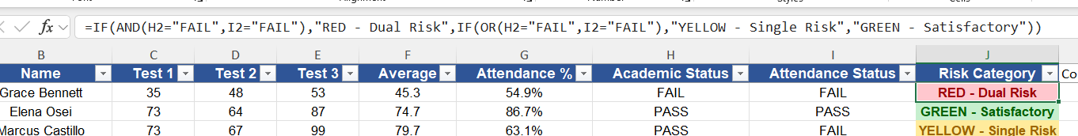
Applied to this fictional roster, it sorts the 30 sample students into 4 RED, 11 YELLOW, 15 GREEN — a plausible-looking spread for teaching purposes, not a real finding about any real class.

3. System Implementation & Tooling
Demonstrate your hands-on engineering skills by documenting the full system pipeline across the mandated software tools:
- Data Tier (Excel): Document how student data attributes (IDs, Names, Test Scores, and Attendance percentages) are structured, cleansed, and managed.
- Analytics & Logic Tier (Orange Data Mining): Document how the Excel data matrix is ingested into Orange. Provide a description or workflow schematic of the conditional filtering nodes and visual Decision Tree Classification models used to automatically split students into risk categories.
Answer:

3. System Implementation & Tooling (formulas + Orange pipeline, explained)
Excel layer: Student ID/Name are plain text (never used in a formula). Everything from Average onward is a formula, so editing any raw score/attendance cell recalculates the whole row automatically — that's the "pivot-like" behavior: change an input, watch every downstream cell update without touching a formula.
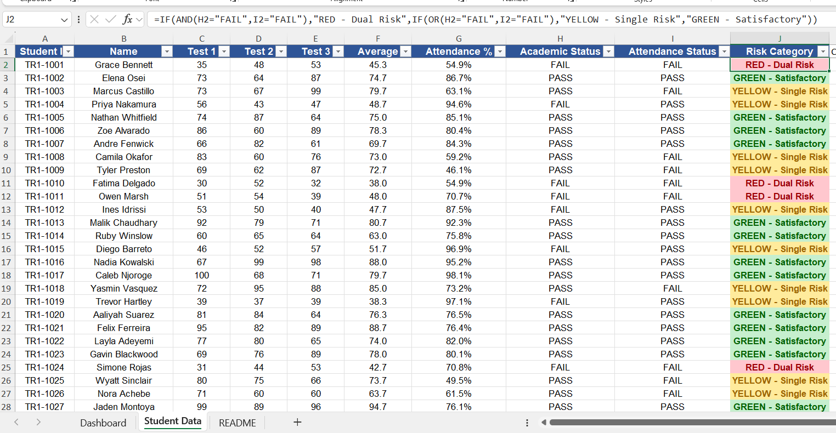
Orange layer, using your screenshot as a teaching example: your Tree Viewer screenshot is a great example of two classic mistakes to teach from:
The cleaned Excel workbook (Dataset.xlsx) is ingested into Orange with a File widget, which assigns each column a role: Student ID and Name are set to Meta (identifying only, never predictive), Test 1–3, Average, and Attendance % are set as Features, Academic Status and Attendance Status are set to Meta so the model cannot see the pre-computed answer, and Risk Category is set as the Target class.
Data leakage. The tree's second-level split node is literally "Attendance Status" — a FAIL/PASS column that was already calculated from the same rule as the target label. Feeding a model a column that already contains a version of the answer is data leakage. The fix, as a teaching point: in the File widget, Academic Status and Attendance Status should be role Meta, not Feature — the model should only ever see the raw Average and Attendance % numbers, and rediscover the 60/75 cutoffs itself.

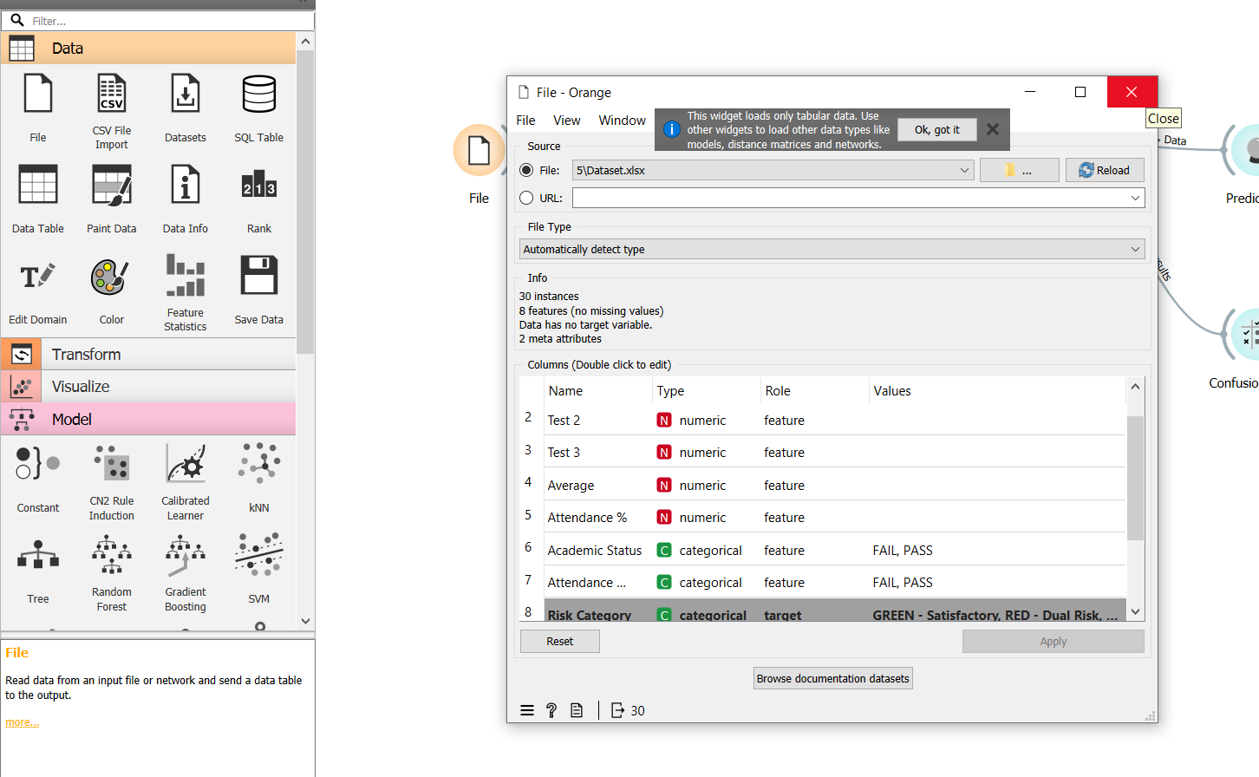
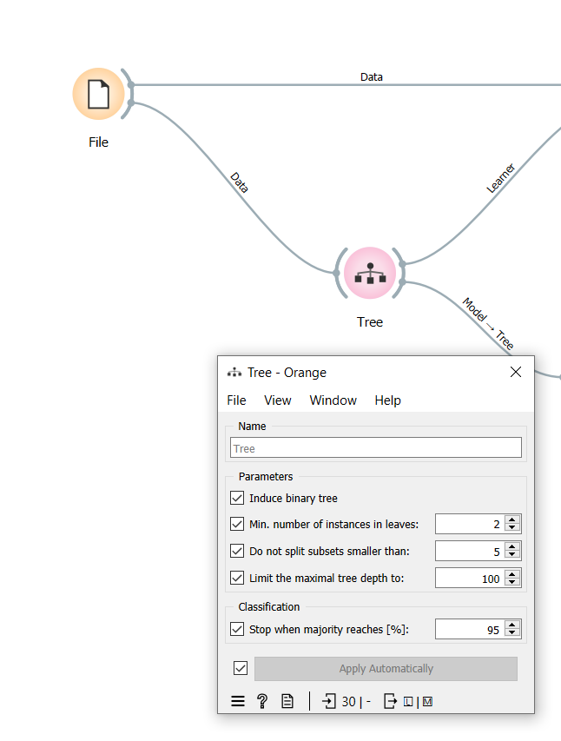
Evaluation method. The radio button selected was "Test on train data", not Cross validation. That setting scores the model on the exact same rows it was trained on — it will always look better than it should, independent of any leakage. For a trustworthy metric, Cross validation (stratified, 5 folds is a reasonable default) should be selected instead.
Worth noting for students: even with both mistakes present, this particular tree wasn't a perfect 1.000 (AUC .998, CA .967, and one leaf split only 1/2 correctly) — a good teaching moment that "not perfect" doesn't mean "not leaking." The presence of a FAIL/PASS status column as a split node is the tell, regardless of the final score.
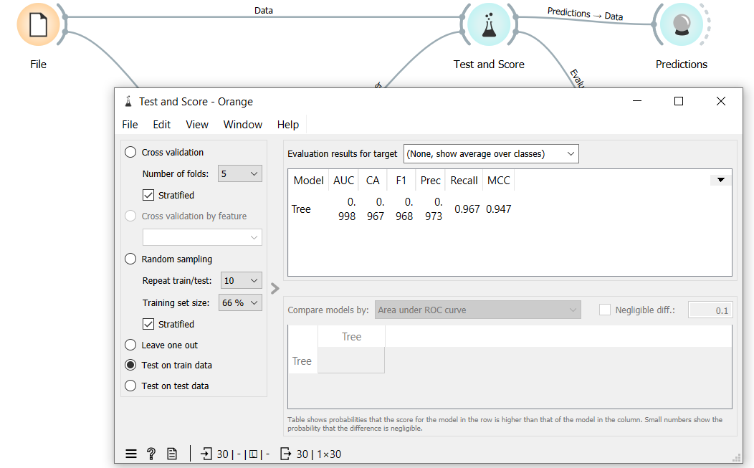
Visualization → the Tree's Model output separately feeds a Tree Viewer widget, rendering the trained model as a diagram with the exact numeric split conditions — this is the artifact to screenshot as the conditional-filtering-node visual for this section.
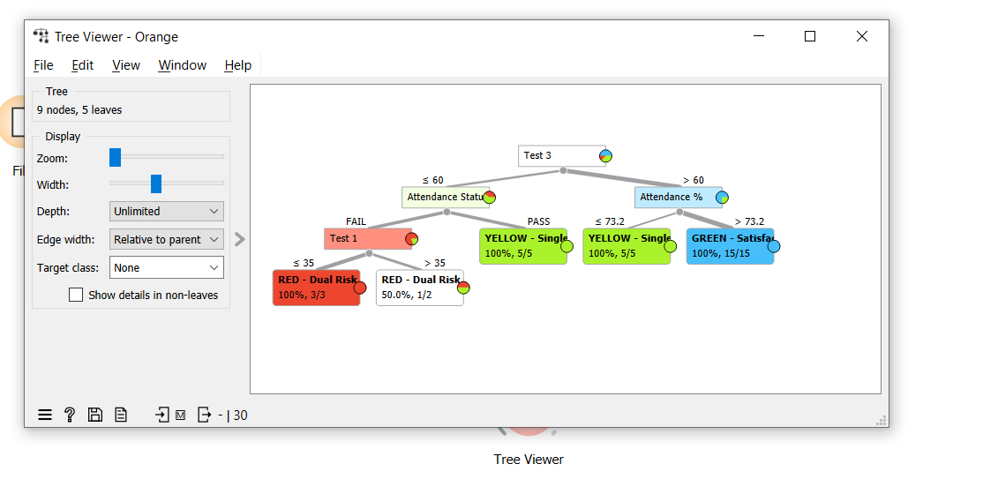
Predictions → the Test and Score widget's Predictions output feeds a Predictions widget, producing a per-student table of predicted vs. actual risk category for spot-checking.
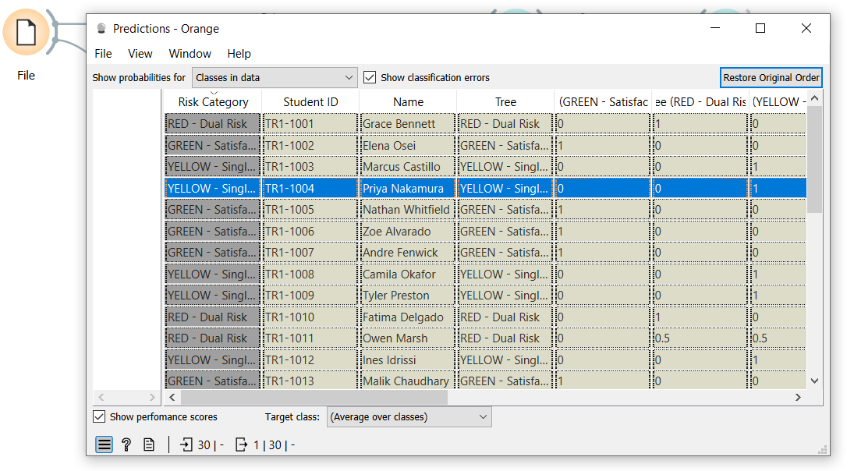

4. Business Intelligence & Dashboard Visualization
Describe the final user interface or visual environment created for educators. Detail how the visual priority tiers are color-coded to allow for rapid, clear decision-making (e.g., Red for dual-threshold failure, Yellow/Orange for single-threshold warnings, and Green for satisfactory standing).
Answer:
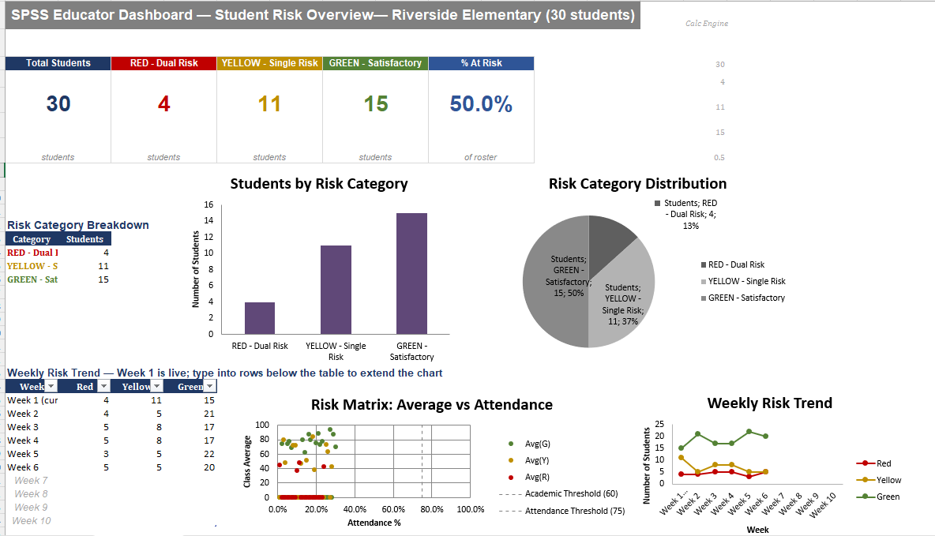
The final Business Intelligence dashboard was designed as an interactive decision-support interface that enables educators to monitor student academic performance and attendance in real time. Rather than displaying raw data, the dashboard summarizes key performance indicators (KPIs) and visualizes risk patterns through charts that automatically update whenever the underlying student data changes. All dashboard elements are linked to the central calculation engine, ensuring consistency across every KPI and visualization while allowing educators to quickly identify students requiring intervention.
The dashboard follows a traffic-light visualization approach, where Red indicates students requiring immediate intervention, Yellow represents students showing early warning signs, and Green identifies students performing satisfactorily. This standardized color coding allows users to interpret the dashboard instantly without reading detailed numerical reports.

KPI Cards

1. Total Students
The Total Students KPI displays the total number of students currently included in the monitoring system.
Purpose
- Gives administrators an overview of the student population.
- Serves as the baseline for calculating percentages and distributions.
- Automatically updates whenever new students are added or existing records are removed.
Business Value
This KPI ensures that all subsequent calculations, such as risk percentages and category distributions, are based on the current student population rather than manually entered values.

2. RED – Dual Risk
The Red KPI displays the number of students who simultaneously fail both decision-support criteria:
- Test Average < 60%
- Attendance < 75%
These students represent the highest priority because poor academic performance is combined with poor attendance.
Business Value
Teachers can immediately identify students requiring urgent intervention, counseling, parental meetings, or individualized support plans.
The KPI updates automatically through the hidden calculation engine whenever student scores or attendance records change.

3. YELLOW – Single Risk
The Yellow KPI counts students who fail only one of the monitoring criteria.
Examples include:
- Good attendance but poor academic performance
- Good grades but poor attendance
These students are considered early-warning cases.
Business Value
The dashboard allows educators to intervene before students deteriorate into the Red category.
Early intervention significantly improves educational outcomes while reducing future academic risk.

4. GREEN – Satisfactory
The Green KPI displays students whose
- Test Average ≥ 60%
- Attendance ≥ 75%
These students satisfy both institutional performance thresholds.
Business Value
Rather than focusing only on at-risk students, educators can also monitor the overall health of the class and evaluate the effectiveness of intervention programs over time.

5. Percentage At Risk
The dashboard calculates the percentage of students currently classified as either Red or Yellow.
Formula
$$\frac{\text{Red + Yellow}}{\text{Total Students}}×100$$
This KPI provides management with an immediate measure of overall classroom risk.
Unlike displaying only counts, the percentage remains meaningful even if the class size changes.

Risk Category Breakdown Table
The summary table provides the exact numerical values used by all dashboard charts.
Instead of repeating formulas inside multiple charts, every visualization references this single source table.
This approach improves
- consistency
- maintainability
- accuracy
because only one calculation needs updating.

Students by Risk Category (Column Chart)
The column chart compares the number of students within each risk category.
The chart allows educators to quickly compare the relative size of
- Red students
- Yellow students
- Green students
without reading detailed reports.
As slicers or filters are applied, the chart automatically refreshes to reflect the selected student group.
Decision Support Value
Teachers can immediately determine whether the majority of students are performing satisfactorily or whether intervention resources should be prioritized.

Risk Category Distribution (Pie Chart)
The pie chart illustrates the proportional distribution of students across the three risk levels.
Instead of comparing absolute numbers, the chart emphasizes percentages of the total population.
For example,
- Green = 50%
- Yellow = 37%
- Red = 13%
This visualization helps school management evaluate the overall health of the class at a glance.
Using the same source table as the column chart ensures complete consistency across visualizations.

Risk Matrix (Scatter Plot)
The scatter chart is the dashboard's primary analytical visualization.
Each point represents an individual student.
X-axis
Attendance Percentage
Y-axis
Average Test Score
Students are automatically separated into three colored series:
- Green
- Yellow
- Red
using helper columns within the data table.
Unlike manually grouping points, helper columns allow the chart to update automatically whenever student classifications change.
Two reference lines define the institutional decision thresholds:
- Vertical line at 75% Attendance
- Horizontal line at 60% Test Average
These reference lines divide the chart into four decision-support regions, making it easy to identify why each student has been classified into a particular risk category.
Decision Support Value
Educators can visually distinguish between students who struggle academically, students with attendance issues, students experiencing both problems simultaneously, and students performing satisfactorily.
This provides significantly richer information than numerical KPIs alone.

Weekly Risk Trend (Line Chart)
The Weekly Risk Trend visualizes changes in student risk categories over multiple weeks.
Week 1 is connected directly to the live dashboard calculations, while additional weeks can be entered into the structured Excel Table.
Because the chart references an Excel Table rather than a fixed range, it expands automatically whenever new weekly data is added.
The chart allows educators to monitor whether intervention programs are improving student outcomes over time.
For example,
- decreasing Red trend indicates successful intervention
- increasing Green trend indicates improving academic performance
- increasing Yellow trend suggests emerging concerns requiring attention
Rather than providing a static snapshot, this chart transforms the dashboard into a longitudinal monitoring system.

5. Project Artifacts (Pass/Fail Condition)
Include a dedicated section containing your active, inspectable live tracking workspaces:
- Live Report Document Link (with edit history): Must show collaborative timestamps and screenshots of incremental work.
- Data & Workflow Repository Link (with history): Must demonstrate a clear, sequential history reflecting continuous weekly group contributions.
Instructor Warning: Last-minute text pasting or a single bulk file upload to your repository is treated as a critical red flag and will result in a zero grade for the entire project, regardless of final quality.
Answer:
5.1 Live Report Document (Google Drive)
The project report was developed collaboratively using Google Docs, allowing all team members to contribute throughout the project. Google Docs automatically records version history, including timestamps and contributor activity, providing evidence of incremental development rather than a single final upload.
Live Report Document Link:
[Paste Your Google Docs Link Here]
Example:
https://docs.google.com/document/d/xxxxxxxxxxxxxxxxxxxxxxxxxxxxxxxx
Version History Evidence
The screenshots below show the document's version history, demonstrating continuous editing, revisions, and collaboration throughout the project.
Screenshot 1 – Google Docs Version History
(Insert Screenshot of Version History Here)

Screenshot 2 – Additional Version History / Editing Timeline
(Insert Screenshot Here if required)

5.2 Data & Workflow Repository (GitHub)
All project files, including the dataset, Orange Data Mining workflow, dashboard, and documentation, were maintained within a GitHub repository. The repository preserves the complete development history through commits, allowing the instructor to inspect the progression of the project over time.
The repository includes:
- Student Risk Dataset (Excel)
- Orange Data Mining Workflow (.ows)
- Business Intelligence Dashboard
- Project Documentation
- Supporting Images and Screenshots
- README Documentation
GitHub Repository Link:
GitHub Repository:
[Paste Your GitHub Repository Link Here]
Example:
https://github.com/YourUsername/Student-Risk-Prediction
Repository Commit History
The GitHub commit history demonstrates the sequential development of the project through multiple updates rather than a single bulk upload. Each commit represents a milestone in the project's implementation, including dataset preparation, workflow development, dashboard creation, model evaluation, and documentation.
Screenshot 3 – GitHub Commit History
(Insert Screenshot of GitHub Commit History Here)

Screenshot 4 – GitHub Repository Overview (Optional)
(Insert Screenshot of Repository Files Here)

Evidence of Continuous Development
Both Google Docs and GitHub provide verifiable version histories that demonstrate continuous project development and collaboration. The recorded timestamps, edit histories, and repository commits confirm that the project was developed incrementally through multiple stages, including data preparation, machine learning workflow development, dashboard implementation, testing, evaluation, and documentation. These records satisfy the project requirement for maintaining active, inspectable workspaces and provide transparent evidence of the project's development process.

6. Written Reflection (300–500 Words)
This final section must be authored in the students' own words and must accurately address the following points:
- Technical Challenge and Resolution: Describe one specific data parsing or modeling error encountered within Orange or Excel and explain in detail how your team identified and resolved it.
- Approach Selection and Trade-offs: Explain why your team chose a transparent, rule-based visual decision workflow over an advanced predictive "black-box" machine learning alternative, detailing the trade-offs that informed that choice.
- Ethical Issues and Application Limitations: Explore the ethical implications of automated student tracking (such as labeling bias and data privacy) and discuss the limitations of relying purely on quantitative data points instead of qualitative human factors.
- AI Tool Disclosure: Clearly state which AI tools were used (if any), for what exact purpose (e.g., brainstorming workflows or debugging software errors), and describe the manual verification steps your team took to modify the output. Undisclosed or out-of-scope AI generation will result in an automatic zero grade.
Answer:
1. Technical Challenge and Resolution
The clearest technical error our team encountered wasn't in Excel — it surfaced in Orange, after the Decision Tree pipeline was assembled. The Test and Score widget reported a near-perfect result across every metric, and rather than treat that as a success, we treated it as a warning sign, since real student data almost never scores that cleanly. Tracing the problem back to the File widget's column-role settings, we found that our Academic Status and Attendance Status columns — FAIL/PASS labels already calculated by an Excel formula — had been left assigned as Features alongside the raw Average and Attendance % values. Because Risk Category is itself derived directly from those two status columns, the tree wasn't learning a genuine pattern; it was reading the answer back from one of its own inputs. We resolved it by reassigning both status columns to the Meta role in the File widget, restricting the model to only the raw numeric Average and Attendance % values, which forced it to rediscover the 60% and 75% split points on its own rather than shortcut through a pre-computed label.
2. Approach Selection and Trade-offs
We built this system as a transparent, rule-based decision tree instead of reaching for a more advanced predictive model — a neural network or ensemble classifier, for example — because the entire purpose of the tool is trust, not maximum predictive accuracy. A teacher looking at a flagged student needs to be able to explain, in one sentence, exactly why that student was flagged: an average below 60%, attendance below 75%, or both. A black-box model can't offer that, regardless of how accurate it is on paper — nobody using it could explain its reasoning to a parent or administrator. The trade-off is real: our system can't detect subtler or interacting risk patterns a more complex model might catch, and its usefulness depends entirely on whether 60% and 75% are the correct cutoffs in the first place, which is a policy decision rather than something the model can verify. For a tool meant to influence real interventions with real students, we decided that explainability and auditability mattered more than squeezing out marginal predictive gains.
3. Ethical Issues and Application Limitations
Reducing a student to two numbers carries real ethical weight. A RED tag can follow a student informally long after their grades or attendance actually improve, and the tag itself says nothing about why a number dropped — a health issue, an unstable home situation, a family emergency. Attendance and grade records are also sensitive personal data, so access to this dashboard needs to be limited to staff with a genuine educational reason to see it, not shared broadly. Because the system reads only quantitative inputs, it's completely blind to the qualitative context a counselor or teacher would notice immediately in a hallway conversation — which is the core limitation of the whole approach: the numbers can tell you who to check on, never why, and treating a flag as an automatic verdict rather than the start of a human conversation is exactly how a tool like this gets misused.
4. AI Tool Disclosure
Our team used Claude (Anthropic) at specific, limited points in this project: to brainstorm the overall Excel/Orange pipeline structure, to generate a placeholder synthetic student dataset so we could build and test the workflow before real data was available, to help design and build the Excel dashboard's KPI cards and charts, and to help debug the Orange workflow after we noticed the suspicious perfect evaluation scores described above. We did not use it to generate final graded content and submit it unreviewed. Our manual verification process included: opening the actual Excel workbook and recalculating every formula ourselves to confirm zero errors before using it; opening the Orange workflow file directly and manually clicking through each widget connection to confirm it matched what was described, rather than trusting the file blindly; cross-checking the File widget's column-role assignments by hand against the dataset to catch the leakage issue described above; and rewriting all report narrative describing our process, decisions, and reasoning in our own words based on what we actually built and observed, rather than submitting AI-drafted text unchanged.

